**MS-CH22K**

**Instruction**

**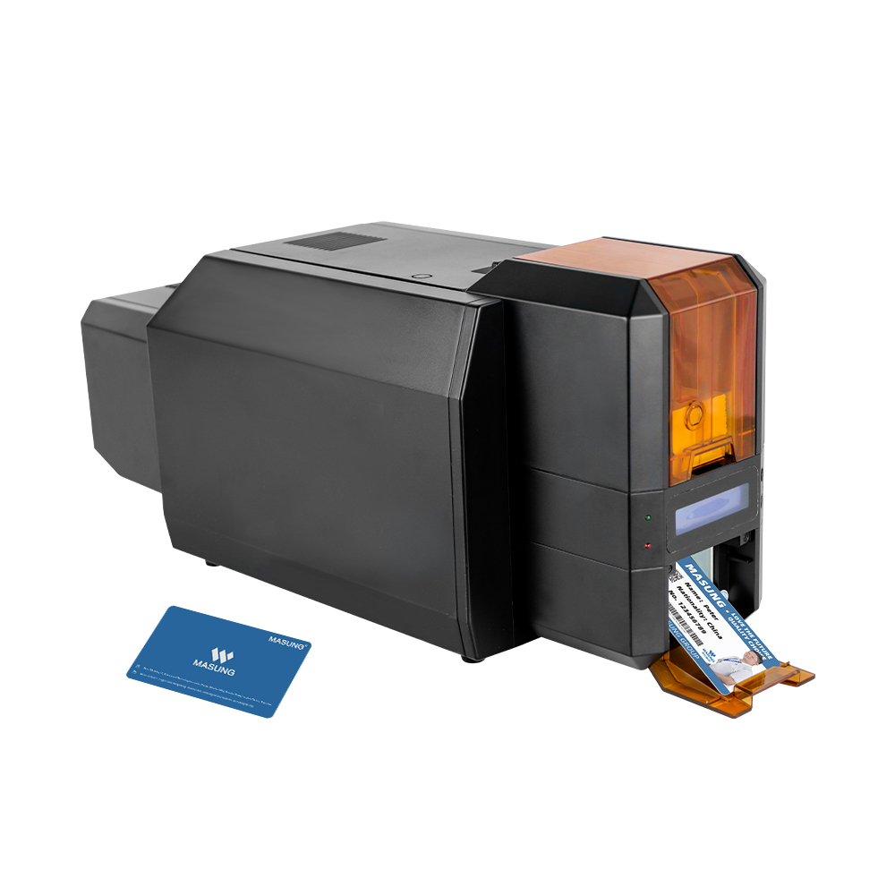**

Revision record

|  |  |  |
| --- | --- | --- |
| Release Date | Version | Remarks |
| 2025.02.13 | V1.0 | 2025collatin documents |
|  |  |  |
|  |  |  |

\* The information provided in this specification is for reference only.

The specific configuration information is subject to the sales contract

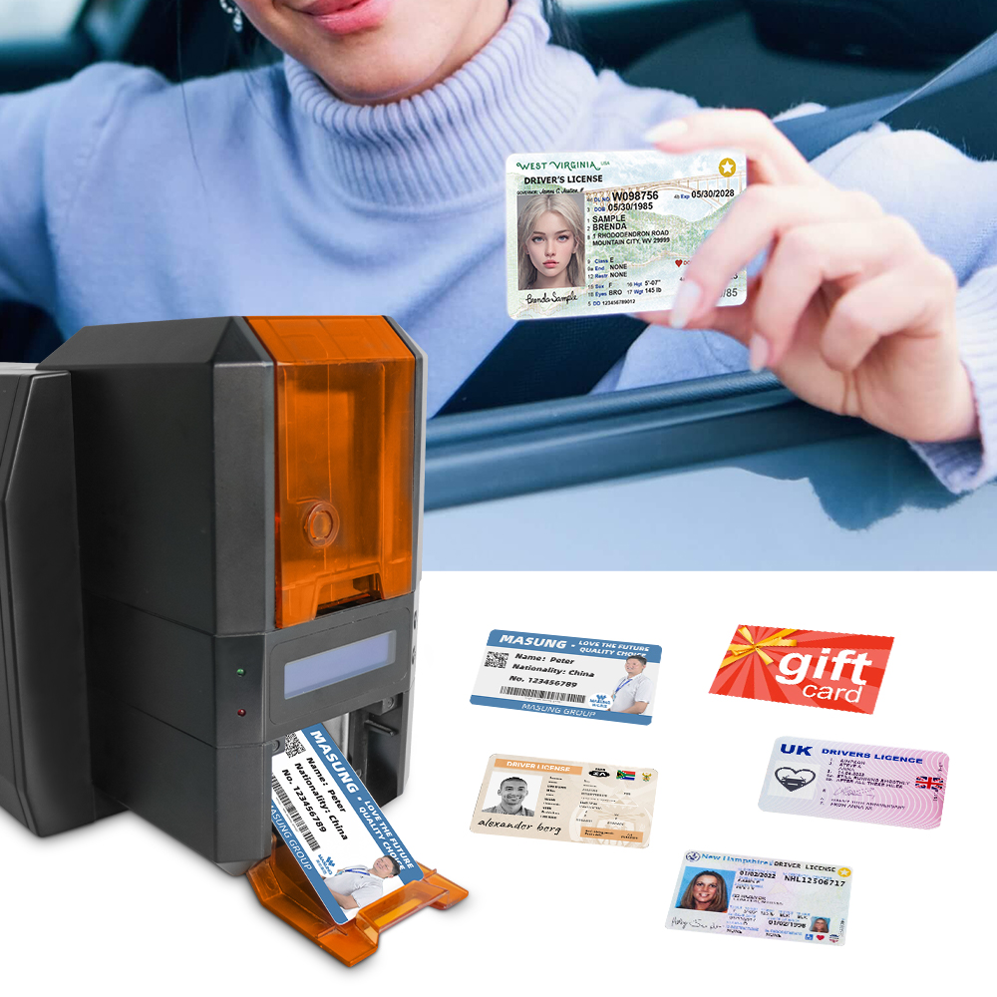

## Table of Contents

[**First：Product Introduction** 4](#_Toc13925)

[**Second：Specification Parameters and Usage Requirements** 4](#_Toc12090)

[1、Main Technical Specifications 4](#_Toc120)

[2、Product Schematic Diagram 5](#_Toc10811)

[**Third：Operation procedures** 6](#_Toc22560)

[1、Printer connection 6](#_Toc31684)

[2、Steps for Using a Printer 6](#_Toc3298)

[**Fourth：Printer Fault Handling and Daily Maintenance** 9](#_Toc25151)

[1、Ribbon Abnormalities 9](#_Toc9410)

[2、Cleaning the Thermal Sensitive Plate of the Print Head 9](#_Toc3888)

[3、Operation Precautions 1](#_Toc1979)0

# First：Product Introduction

# The MS-CH22K is a color ID card printer. It adopts the thermal sublimation printing method and supports double-sided printing. The printed cards are clear, and it is equipped with a card hopper. This device is connected via USB and is typeset by specific computer software. This software has a design style similar to Microsoft Office software, with a user-friendly modular design, convenient and practical database connection, support for personalized layout, and a rich background image library. It is convenient to print, highly reliable, and simple to operate and maintain.

# Second：Specification Parameters and Usage Requirements

## 1、Main Technical Specifications

These technical specifications are applicable to the MS-CH22K structural printing module

|  |  |
| --- | --- |
| **Model** | MS-CH22K |
| **Product Name** | Thermal Sublimation ID Card Printer |
| **Printer speed** | Single-sided monochrome: 4.8 seconds per card Single-sided color: 20 seconds per card  Double-sided monochrome:12 seconds per card Double-sided color: 42 seconds per card |
| **Feed Method** | The card slot automatically feeds the card. |
| **Card slot capacity** | 100 cards (0.76mm thick) |
| **Resolution** | 300DPI |
| **Admissible card size** | CR-80(53.98mm X 85.6mm) |
| **Card - feeding thickness** | 0.3mm-2.0mm |
| **Printable materials** | PVC or PVC composite card |
| **Ribbon Type** | Specialized ribbon (with RFID) |
| **Communication Interface** | USB 2.0, Ethernet interface (optional), RS232 interface (optional) |
| **Operating Voltage and Current** | Input: AC 100-240V,1.5A, 50-60Hz  Output: DC 24V, 2.5A |
| **Operating Temperature** | 5℃ - 40℃ (no condensation) |
| **Operating Relative Humidity** | 25~85%RH (no condensation) |
| **Storage Temperature**  **(Whole Machine)** | -20~60℃ (no condensation) |
| **Storage Temperature (Ribbon)** | -10~40℃ (no condensation) |
| **Storage Relative Humidity** | 10~90%RH (no condensation) |
| **Net Weight** | 6KG |
| **Overall Dimensions** | 508mm (L) x 188mm (W) x 238mm (H) |

## 2、Product Schematic Diagram

## IMG_256

## IMG_256

## IMG_256

**power port**

**RS232 port**

**Ethernet port**

**USB port**

**Rear card outlet**

**A/B button**

**LCD monitor**

**power switch**

**LED indicator**

**light**

# Third:Operation Procedures

## 1. Printer Connection

① Check whether the input power supply voltage of the printer is within the range specified in the instruction manual.  
② After connecting the power supply, use a USB cable to connect the printer to the host computer. Observe whether the printer is working properly (the display screen is displaying normally). If not, turn off the power immediately.

Note: Do not use this machine in an environment with direct strong light, as it may trigger the photoelectric sensor in the printer and cause misoperation. The usage environment should be clean and dry, and regular maintenance should be carried out.

## Steps for using the printer

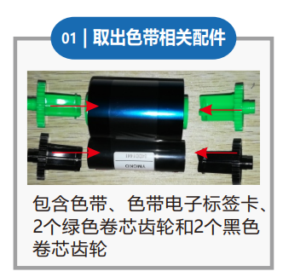

**②Assemble the ribbon.**

**①Take out the relevant accessories of the ribbon.**

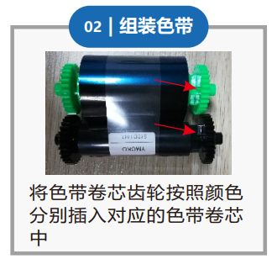

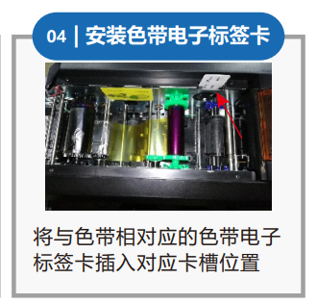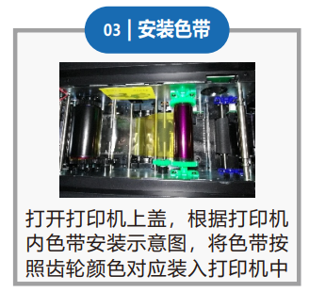

Insert the ribbon core-rolling gears into the corresponding ribbon cores according to their colors.

Insert the ribbon electronic tag card corresponding to the ribbon into the corresponding card slot.

Open the upper cover of the printer. According to the ribbon installation diagram inside the printer, install the ribbon into the printer by matching the color of the gears.

It includes the ribbon, the ribbon electronic tag card, two green core-rolling gears and two black core-rolling gears.

**④Install the ribbon electronic tag card.**

**③Assemble the ribbon.**

**⑤Install the cleaning wheel.**

**⑥Adjust the card - feeding thickness.**

Open the upper cover of the card - feeding slot. Move the card - thickness adjustment cursor left and right so that a single card can pass smoothly through the lower card - feeding opening, but two cards cannot pass through simultaneously.

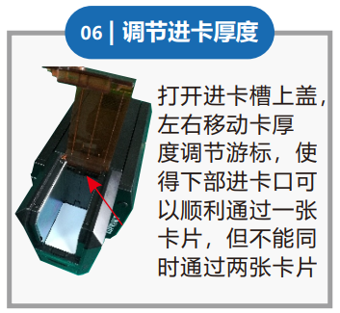

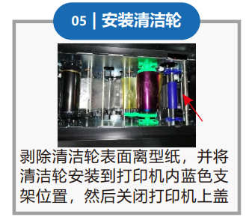

Peel off the release paper on the surface of the cleaning wheel, install the cleaning wheel on the blue bracket inside the printer, and then close the upper cover of the printer.

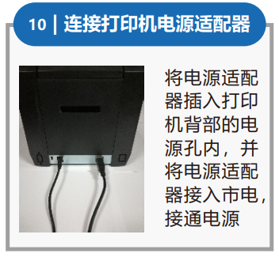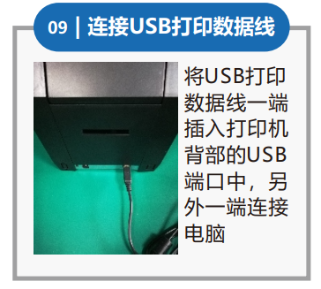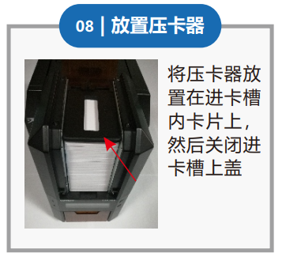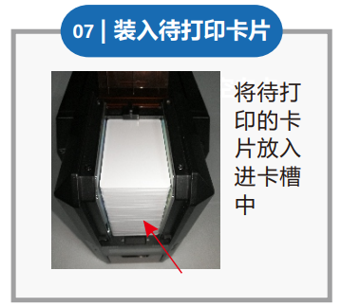

Connect the USB cable

Connect the power

adapter of the printer.

Put the card to be printed into the card magazine.

Place the card presser on the card in the card - feeding slot, and then close the upper cover of the card - feeding magazine.

**⑩Connect the power**

**adapter of the printer.**

**⑨Connect the USB**

**printing data cable.**

**⑧Place the card presser.**

**⑦Load the card to be printed.**

**12,Install the printer driver**

**11,Power on**

Press the power button in the front of the printer. The LCD screen will display the boot - up interface, and the green indicator light will be on constantly.

Get the corresponding printer driver from the accompanying CD - ROM or the official website, and install the printer according to the prompts.

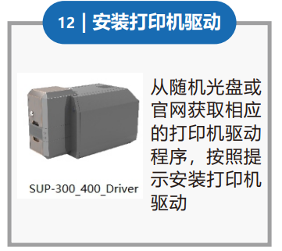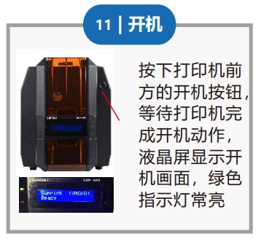

**14,Configure the printer parameters**

**13,Check the printer parameters**

Set appropriate parameters in the driver parameter settings according to the actual usage.

You can obtain printer information in the properties of the printer driver.

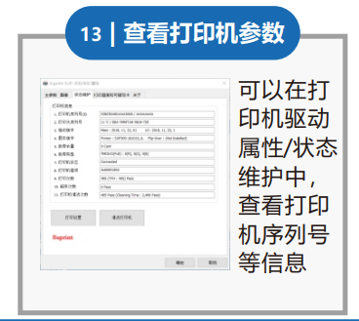

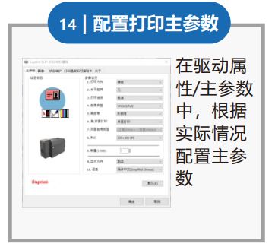

**16,Obtain the print test card.**

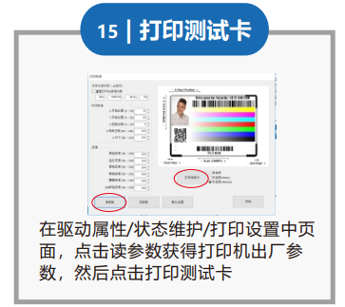

**15,Print the test card.**

## d589640a2080c6689e36dda53b70040c

Get the printer's factory - default parameters in the driver properties, and then click to print the test card.

After the printing action is completed, open the cover of the output slot and take out the print test card.

# Fourth：Printer Fault Handling and Daily Maintenance

## 1. Ribbon Abnormalities

### ① The printer has a ribbon and is printing, but the print quality or content has defects:

* Check whether the ribbon is intact and whether there are any impurities remaining.
* There may be impurities on the thermal sensitive plate or it may be damaged. Check and clean the thermal sensitive plate. If the impurities on the thermal sensitive plate cannot be removed, please contact our company for replacement. (Replacement is not provided in case of improper operation or improper storage.)
* Is your ribbon compatible with the printer? When the printed pattern exceeds the printable width of the printer, the excess pattern will be automatically ignored by the printer.
* Clean the thermal sensitive plate: Remove the ribbon and use a cotton swab and anhydrous ethanol (alcohol) to wipe the position of the thermal sensitive plate to enhance the printing effect.

**② The printer does not print after data is sent: (Before sending data, query the printer status multiple times. Data can be sent when the printer status shows normal.)**

* Query the printer status.
* Check whether the ribbon is installed correctly and whether it is installed in reverse.
* Check whether the sent data content meets the printing requirements of the printer.
* Press the print head lift button to lift the print head, then press the ribbon take-up button. Observe whether the ribbon shaft operates. If there is no response after pressing, press the print head lift button to lower the print head, turn off the power, and contact our company.

## 2. Cleaning the Thermal Sensitive Plate of the Print Head

* Press the print head lift button to lift the print head, and then turn off the power.
* Use an alcohol swab (squeezed dry) to wipe off the dust and dirt on the thermal sensitive plate of the print head.
* If the printer has just finished printing, wait 10 - 20 minutes for the printer to cool down to room temperature.
* After the cleaning solution has completely evaporated, the printer can be powered on for printing.

## 3. Operation Precautions

1. It is strictly prohibited to manually flip, press the print head, or use force.
2. It is strictly prohibited to use the printer in a humid environment to avoid personal injury.
3. It is strictly prohibited for children without safety awareness to operate this printer.
4. Before powering on the printer, check whether the power cord is safe.
5. Once the printer generates heat, smokes, or gives off an abnormal smell, immediately turn off the power, stay away from the printer, and contact our company.
6. Before sending data, be sure to check the printer status.
7. When the printer is executing a printing task, it does not receive new task data. New task data can be normally received only after the printing is completed and the next batch of silk ribbon is automatically loaded in place. Otherwise, errors are likely to occur.
8. If the printer is not used for a long time, unplug all the connection cables; otherwise, the printer is likely to be damaged.
9. Regularly clean the thermal sensitive plate to maintain print quality.
10. Do not disassemble or drag the printer casually. If there is a fault, turn off the power and contact our company.
11. It is prohibited for foreign objects (staples, metal pieces, liquids, etc.) to enter the machine, otherwise, it may cause electric shock or machine failure.
12. Do not touch the metal parts of the print cable connector and the print head. Do not touch the print head when it is working.
13. Do not use sharp tools such as tweezers to scratch the thermal sensitive plate of the print head and the sensor, otherwise, it will affect the normal use of the printer.

The manufacturer reserves the right to modify the content of this

instruction manual without prior notice!