**MS-CH03**

**Instruction**

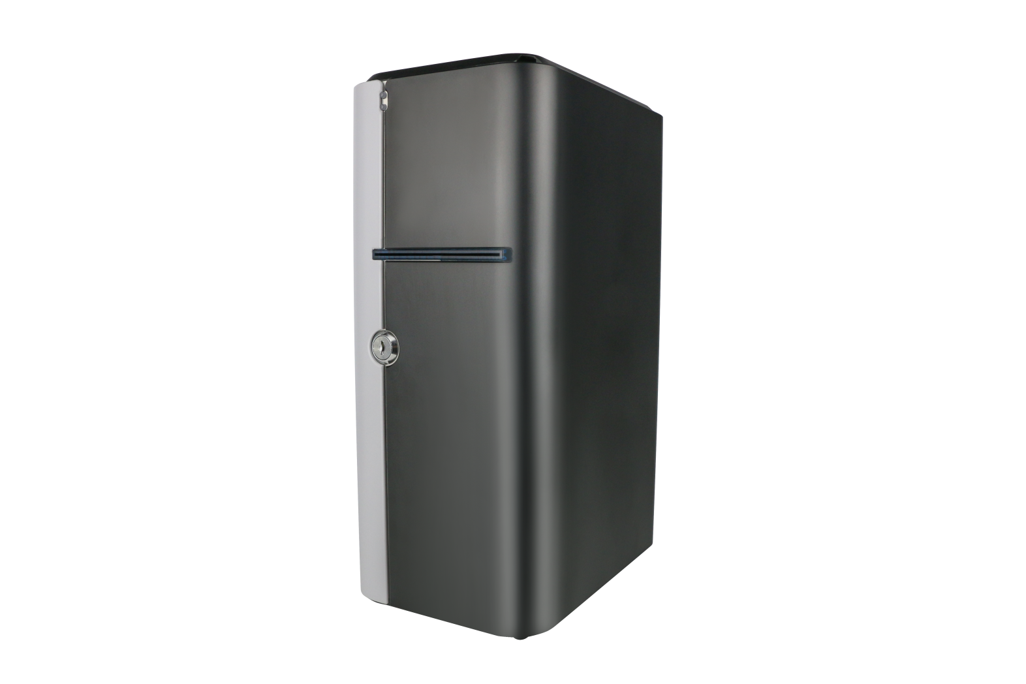

Revision record

|  |  |  |
| --- | --- | --- |
| Release Date | Version | Remarks |
| 2025.02.13 | V1.0 | 2025collatin documents |
|  |  |  |
|  |  |  |

* The information provided in this specification is for reference only.

The specific configuration information is subject to the sales contract

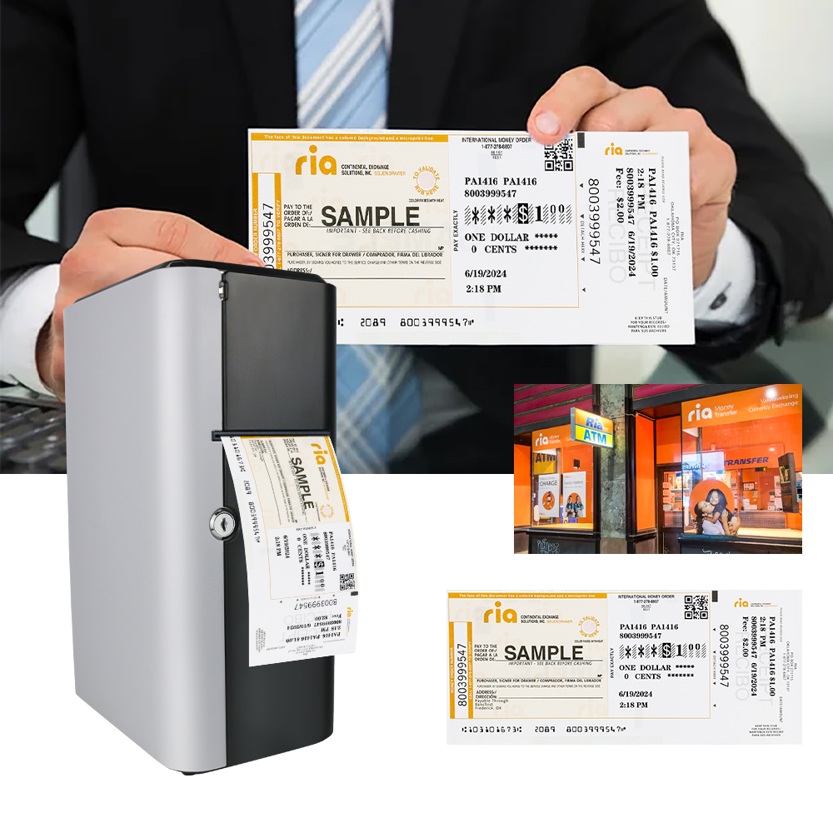

## Table of Contents

**First：Product Introduction** 4

**Second：Specification Parameters and Usage Requirements** 4

1、Main Technical Specifications 4

2、Product Schematic Diagram 5

**Third：Operation procedures** 6

1、Printer connection 6

2、Ribbon installation and replacement 6

3、Paper installation 8

**Fourth：Printer Fault Handling and Daily Maintenance** 8

1、Ribbon Abnormalities 8

2、Cleaning the Thermal Sensitive Plate of the Print Head 9

3、Cleaning of the Paper Slot and Paper feeding Section  9

4、Operation Precautions 9

# First：Product Introduction

The MS-CH03 is a check printer. It uses the thermal transfer printing method, which can produce clear text. It supports the adjustment of printing density and is designed with a ticket bin. This device is connected via USB, and the printing content can be typeset and edited on a computer.

This printer is a professional one specifically designed to prevent banks from returning checks due to improper filling. It replaces the manual filling of checks. Meanwhile, its printing effect can effectively prevent the alteration of checks, ensuring the safety of the funds of the account-opening units and improving the work efficiency of financial staff. It is convenient and quick to print, highly reliable, and easy to operate and maintain.

# Second：Specification Parameters and Usage Requirements

## 1、Main Technical Specifications

These technical specifications are applicable to the MS-CH03 structural printing module

|  |  |
| --- | --- |
| **Model** | MS-CH03 |
| **Product Name** | Thermal Transfer Check Printer |
| **Printable Thickness** | 0.06-0.12mm |
| **Feed Method** | Automatic paper feeding from the paper bin |
| **Paper Feed Speed** | 120mm/s |
| **Resolution** | 203DPI |
| **Maximum Printable Width** | 80mm (MAX) |
| **Ribbon Type** | Wax-based, Mixed-based |
| **Communication Interface** | USB |
| **Operating Voltage and Current** | Input: AC 100-240V,1.5A, 50-60Hz  Output: DC 24V, 2.5A |
| **Operating Temperature** | 0℃ - 40℃ (no condensation) |
| **Operating Relative Humidity** | 20~85%RH (no condensation) |
| **Storage Temperature**  **(Whole Machine)** | -20~60℃ (no condensation) |
| **Storage Temperature (Ribbon)** | -10~40℃ (no condensation) |
| **Storage Relative Humidity** | 10~90%RH (no condensation) |
| **Net Weight** | 3KG(excluding paper roll) |
| **Overall Dimensions** | 320mmx180mmx210mm |
| **Reliability** | 50km |

## 2、Product Schematic Diagram

**Status light**

## _cgi-bin_mmwebwx-bin_webwxgetmsgimg__&MsgID=3801907876477408607&skey=@crypt_88ff6f2b_1d97f97c448a31ebe364eb93cfb46d8e&mmweb_appid=wx_webfilehelper

**Paper outlet**

**Lock**

## _cgi-bin_mmwebwx-bin_webwxgetmsgimg__&MsgID=361543465256787152&skey=@crypt_88ff6f2b_1d97f97c448a31ebe364eb93cfb46d8e&mmweb_appid=wx_webfilehelper

## USB Interface-A

**Power port**

**Ethernet port**

## USB Interface-B

# Third:Operation Procedures

## 1. Printer Connection

① Check whether the input power supply voltage of the printer is within the range specified in the instruction manual.  
② After connecting the power supply, use a USB cable to connect the printer to the host computer. Observe whether the printer is working properly. If not, turn off the power immediately.

Note: Do not use this machine in an environment with direct strong light, as it may trigger the photoelectric sensor in the printer and cause misoperation. The usage environment should be clean and dry, and regular maintenance should be carried out.

## Ribbon Installation and Replacement

## Ribbon Installation:

②Press the print head button to open the print head.

①Insert the key and turn it counter - clockwise to open the main unit compartment door.

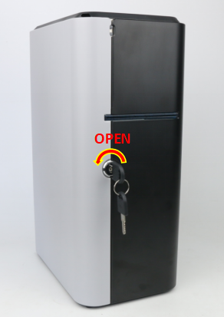

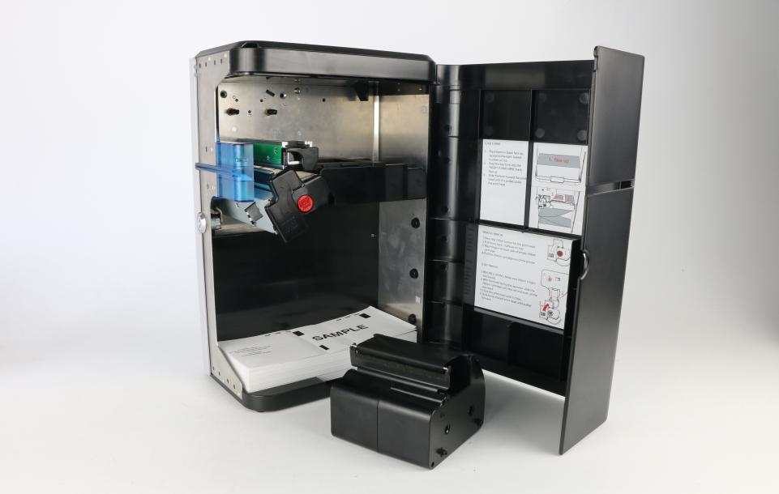

③The front side of the ribbon cartridge.

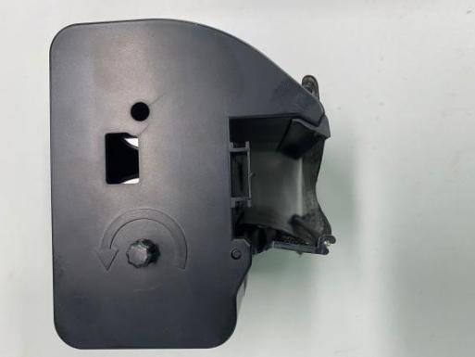

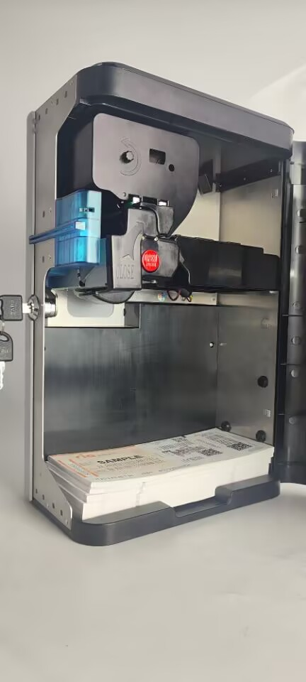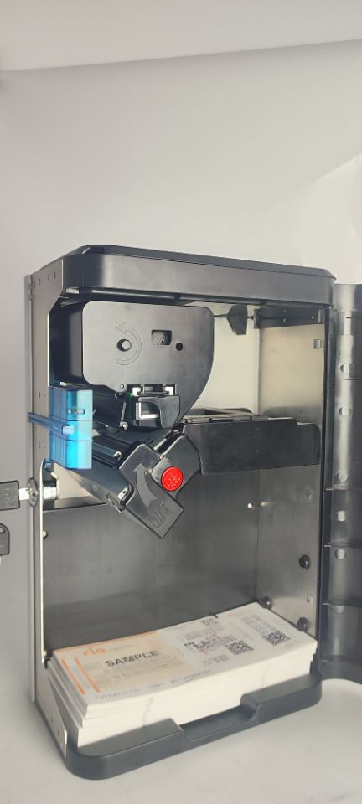

⑤Push the new thermal ribbon in along the guide rail, then close the print head upwards. Pay attention to make sure that the side with the rotation button of the ribbon cartridge faces outward.

④Push the new thermal ribbon along the guide rail inward, and then close the print head upward. Please note that the side of the ribbon cartridge rotation button should face outward.

**3、Paper Installation**

①The check paper needs to be fed into the paper inlet as shown in the picture until the printer can automatically feed the paper.

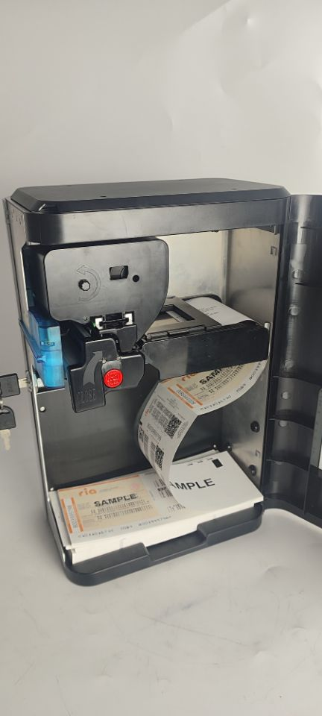

# Fourth：Printer Fault Handling and Daily Maintenance

## 1. Ribbon Abnormalities

### ① The printer has a ribbon and is printing, but the print quality or content has defects:

* Check whether the ribbon is intact and whether there are any impurities remaining.
* There may be impurities on the thermal sensitive plate or it may be damaged. Check and clean the thermal sensitive plate. If the impurities on the thermal sensitive plate cannot be removed, please contact our company for replacement. (Replacement is not provided in case of improper operation or improper storage.)
* Is your ribbon compatible with the printer? When the printed pattern exceeds the printable width of the printer, the excess pattern will be automatically ignored by the printer.
* Clean the thermal sensitive plate: Remove the ribbon and use a cotton swab and anhydrous ethanol (alcohol) to wipe the position of the thermal sensitive plate to enhance the printing effect.

**② The printer does not print after data is sent: (Before sending data, query the printer status multiple times. Data can be sent when the printer status shows normal.)**

* Query the printer status.
* Check whether the ribbon is installed correctly and whether it is installed in reverse.
* Check whether the sent data content meets the printing requirements of the printer.
* Press the print head lift button to lift the print head, then press the ribbon take-up button. Observe whether the ribbon shaft operates. If there is no response after pressing, press the print head lift button to lower the print head, turn off the power, and contact our company.

## 2. Cleaning the Thermal Sensitive Plate of the Print Head

* Press the cover opening button to lift the print head, and then turn off the power supply.
* Use an alcohol swab (squeezed dry) to wipe off the dust and dirt on the thermal sensitive plate of the print head.
* If the printer has just finished printing, wait 10 - 20 minutes for the printer to cool down to room temperature.
* After the cleaning solution has completely evaporated, the printer can be powered on for printing.

## 3.Cleaning of the Paper Slot and the Paper-feeding Part

* After the paper gets jammed, press the button to open the print head.
* Remove all the jammed papers from the paper slot and the paper-feeding channel.
* Otherwise, it will affect the paper-feeding and printing functions of the printer.

## 4. Operation Precautions

1. It is strictly prohibited to manually flip, press the print head, or use force.
2. It is strictly prohibited to use the printer in a humid environment to avoid personal injury.
3. It is strictly prohibited for children without safety awareness to operate this printer.
4. Before powering on the printer, check whether the power cord is safe.
5. Once the printer generates heat, smokes, or gives off an abnormal smell, immediately turn off the power, stay away from the printer, and contact our company.
6. Before sending data, be sure to check the printer status.
7. When the printer is executing a printing task, it does not receive new task data. New task data can be normally received only after the printing is completed and the next batch of silk ribbon is automatically loaded in place. Otherwise, errors are likely to occur.
8. If the printer is not used for a long time, unplug all the connection cables; otherwise, the printer is likely to be damaged.
9. Regularly clean the thermal sensitive plate to maintain print quality.
10. Do not disassemble or drag the printer casually. If there is a fault, turn off the power and contact our company.
11. It is prohibited for foreign objects (staples, metal pieces, liquids, etc.) to enter the machine, otherwise, it may cause electric shock or machine failure.
12. Do not touch the metal parts of the print cable connector and the print head. Do not touch the print head when it is working.
13. Do not use sharp tools such as tweezers to scratch the thermal sensitive plate of the print head and the sensor, otherwise, it will affect the normal use of the printer.

The manufacturer reserves the right to modify the content of this

instruction manual without prior notice!